Weekly Letter 14
English 1 – Beery
November 14-18
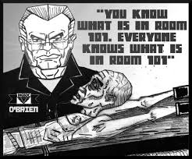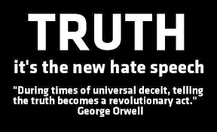
As you can imagine, authority figures need to be trusted. What happens when your leader is not trustworthy? What do you do?
How do this people rise to power?
What does this say about our society?
The authority figures in 1984 are mostly untrustworthy, and there is no authority other than the legitimate authority. And yet Ingsoc, or English Socialism, is not as simple and two-dimensional as it may seem at first. While you read, notice the lengths to which The Party must go to eliminate, or at least control, normal human interaction, thoughtfulness and trust. Even if Orwell was clearly wrong about when human beings would become so isolated from each other, can you see signs of some of his dystopian vision creeping into 21st century society?
Core Questions for Quarter 2 & 1984:
As consumers of information, who do I believe?

Continue to read and compare this week and be ready to prepare for your next expository/comparison essay this quarter. Be sure to extract strong text evidence and the page numbers from your text to help you in this journey.

M Weekly Letter:
Silently Read Ch 2
Winston Character Matrix
HMWK: Book III ch 2 pp 236-260---finish character matrix for homework

T Review Reading Book II and beginning of Book III in 1984
Review character Matrix---move to theme
HMWK: Finish book III chapter 2 for homework and complete Book I & II Characterization Matrix on Winston

W Review Winston Character Matrix Book III Together in class
Theme Activity----how do these characters develop theme

HMWK: Finish reading 1984 by Monday, November 21st (test is on Monday)

How has Orwell’s themes in 1984 generated an applicable theme for our society?
  - Lack of Freedom
  - Conformity
  - Manipulation
  - Relationships
  - Dangers of technology
  - Dehumanization

TH On-Demand Characterization Essay Test-- process character matrix and master :
- I can determine how specific details in the text reveal and continually refine a theme.
- I can analyze how complex characters develop over the course of the grade-appropriate text, interact with other characters, and advance the plot of a text or develop the theme.
- I can analyze how specific word choices build upon one another to create a cumulative impact on the overall meaning and tone of a text (i.e., denotative, connotative, figurative)
HMWK: Finish reading 1984 by Monday, November 21st (test is on Monday)

F
Study Guide Completion: You can work with Catcher in the Rye Partner
The Study guide is strictly for studying---I will not collect it.

HMWK: Finish reading 1984 by Monday, November 21st & study for the test on Monday)
Check the learning goals:

- I can read closely and find answers explicitly in text and answers that require an inference
- I can thoroughly support both explicit and inferential questions by analyzing an author’s words and determining multiple pieces of textual evidence that strongly support those questions.
- I can determine how specific details in the text reveal and continually refine a theme.
- I can analyze how complex characters develop over the course of the grade-appropriate text, interact with other characters, and advance the plot of a text or develop the theme.
- I can analyze how specific word choices build upon one another to create a cumulative impact on the overall meaning and tone of a text (i.e., denotative, connotative, figurative)
- I can analyze substantive topics or texts to compare information
- I can determine the credibility of a source and the accuracy of the details presented in the source.
- I can analyze the context of various texts and determine how language choice affects meaning, style, and comprehension. (test will have cold reads you have never read before---must apply reading skills to new works).

